
The Un-Switching Protocol

by Deena Zalkind Spear

www.singingwoods.org

The body uses electrical impulses through the nervous system as a way to communicate with itself. When emotional, chemical, physical, or nutritional stresses cause an overload in the body, these electrical impulses can become switched, acting like short circuits and transmitting misinformation. Switching also shows itself as some forms of distorted “chi” in the acupuncture meridian system.

Symptoms of being switched can include brain fog, difficulty following directions, fear, anxiety, feeling scattered, and mood changes. This protocol offers a fast and effective way to get the circuits of your nervous system back in order—un-switched.

If one is functioning with the appropriate flow of electrical impulses—un-switched—valuable information can be obtained from the relative strong or weak response of muscles tested under various conditions. This includes knowledge of what substances are in harmony with the body as well as uncovering thoughts, emotions, and beliefs that have been hidden or ignored. Once one becomes aware of thoughts and beliefs that have not been conscious, new choices of perceptions and beliefs can be made that support emotional and physical health.

Being switched makes accurate testing of the muscles impossible. Applied Kinesiology (AK) is a modality that uses muscle testing in order to obtain information about neurological, muscular, and skeletal body functions. AK has a protocol that deals with several layers of switching in order to correct the situation. At the deeper layers of switching, cranial adjustments performed by a trained chiropractor have been required.

Dr. Jessica Loda, a chiropractor trained and certified in Applied Kinesiology, and I, trained (and certifiable) in desperation, originally set out to create a protocol that people could do for themselves, which would work even on the deepest layers of switching. The Un-Switching Protocol is the happy result of our joint endeavor.

In addition to being a self-help method for un-switching, we have also observed this protocol to be useful in ways we had not anticipated. It seems that as one unscrambles some crossed electrical signals in the body, it also becomes easier to attain a grounded state—having one’s consciousness fully in the body, rather than operating mostly from the head and intellect or being “out there” and spacey.

Grounding is essential for effective emotional process work—the steppingstone to a healthier and more heartfelt life. With The Un-Switching Protocol as an additional tool, I have been so happy to observe that more of my clients are able to get deeply into their feelings and make more rapid progress in changing physical conditions, even including such serious illness as late stage cancer.
The Prelude to the Ice Cream Cone Energy Egg and The Ice Cream Cone Energy Egg are two protocols on my website (www.singingwoods.org) that can help many people ground. However, some people are so unaccustomed to having their energy and awareness fully in the body, they try to do even the Prelude exercise from their head, which doesn’t work. Jessica and I discovered that doing The Un-Switching Protocol prior to the other exercises offers a window of about 11 minutes for even the chronically ungrounded to stay un-switched. This is long enough for most of those previously unable to do the Prelude to now perform it successfully and continue on to make the Egg—at long last achieving grounding. (An ungrounded person will often not stay un-switched, and a switched person will often have more trouble grounding. The Un-Switching Protocol usually seems to resolve this Catch 22.)

Even if a person is already grounded, The Un-Switching Protocol can be done on its own prior to muscle testing, prior to working with the emotions, and instead of trading in the current body and mind for a different model and year.

There are additional self-help protocols that I am creating in partnership with Jessica and others. They will be available in the Articles section of my website as they are completed. One of these, called Stay Tuned, is most effective if one is already grounded before doing it and is further enhanced by performing The Un-Switching Protocol just before undertaking it.

The Steps to Un-Switch

This entire protocol can be performed in a seated position. (While Step 2 must be done while sitting, the other steps can also be carried out lying down if you wish.) Once learned, the entire exercise takes only a minute. It can be done whenever and as often as you choose—day or night. Have at least a few sips of unchlorinated water just before beginning. Being hydrated is essential to staying un-switched. To further enhance the exercise, gently imagine the color of late spring green grass with a touch of light blue as you begin.

Step 1. Diaphragm.

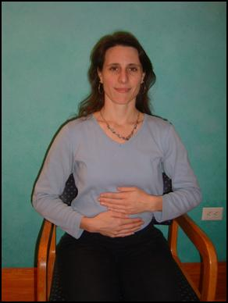
Place one hand above the other on the diaphragm point, which is found just underneath the xiphoid process—the lowest portion of the center bone of the rib cage (the sternum). The hands are placed in a horizontal position with the palms against the abdomen and are positioned edge to edge with the horizontal pinky of one hand touching the horizontal thumb of the hand below it. It does not matter which hand is closest to the rib cage and which is closest to the belly button. Take 3 breaths, inhaling through the nose and exhaling through the mouth. Begin the count on the in-breath. This first step activates the neurological and energy systems of the body.

Step 2. In the Prophetic Position.
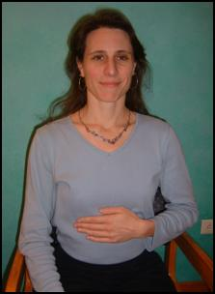

It is important to do the
hand placement of this
step in the order given.

First, place either
hand horizontally on
the diaphragm point.

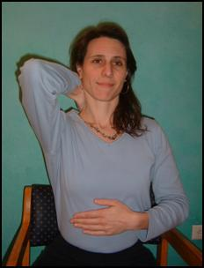
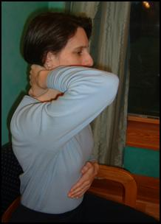

Next place the other hand horizontally on the middle
of the back of the neck with
the palm against the neck.

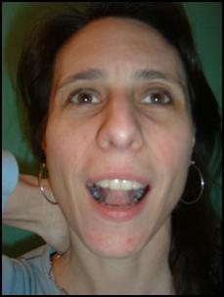

Then place the tip of your
tongue approximately in the
center of the roof of your mouth
at the high point of the arch.

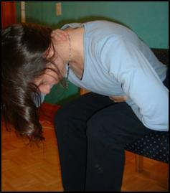

With both hands and the tongue in position, press on the back of your neck as you bend forward.

Your head can be above, at, or below the knees, just so you are bent forward. In this bent position—hands and tongue still in place and with the hand at the back of the neck still pressing on the neck—breathe in through the nose and out through the mouth approximately 4 to 6 times. (Step 2, even by itself, can help clear brain fog.)

Step 3. Collarbones.
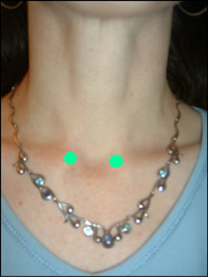

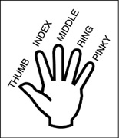
Place the index and middle fingers
of one hand on the point at the end
of the collarbone that is on the same
side of the body as the hand.

(This point is called Kidney 27, or K27
for short, in traditional acupuncture.)

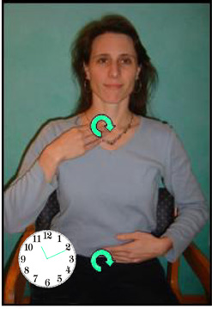
You can begin with either hand, but it is important to use your right hand on your right collarbone and your left hand on your left collarbone. As an example, if you choose to begin with your right hand, place it on the end of the collarbone found just above and slightly to the side of the v-shaped groove centered at the bottom of the front of your neck. If necessary, you can lift up your right shoulder for a moment, making the collarbone more prominent so you can locate the end of it. As soon as you have located the collarbone point, relax your shoulder. Place the index and middle fingers of your other hand on your belly button. Rub the collarbone point and your belly button at the same time in a clockwise motion. Clockwise in this case would be from the perspective of someone standing and looking at you from the front. (Your skin moves with your fingertips as you make small circles on the collarbone and belly button points.) Usually about 15 to 20 seconds of this circular rubbing is sufficient.

If you are having a lot of difficulty rubbing with both your hands moving clockwise, you may find it helpful to stop and do some calming breathing. Put your tongue just behind, but not touching, the top of your two front teeth. Inhale through the nose and exhale through the mouth. When you do the exercise again, be sure you continue to breathe, rather than holding your breath. Breathe in through the nose and exhale either through the nose or mouth. (Have someone observe if you are still not clear about clockwise.)
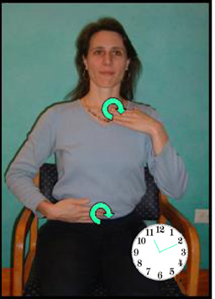
When one side is complete, reverse hands: If you had your right hand on the right collarbone, now put your left hand index and middle fingers on the left collarbone and the other hand index and middle fingers on your belly button. Again rub clockwise (as viewed from an observer facing you from the front) for about 15 to 20 seconds.

(If you cannot visualize the perspective of an observer, another way to understand this is: move your hand from your right to your left on the upper part of the circle, and from your left to your right on the lower part of the circle.)
Step 4. Tailbone.
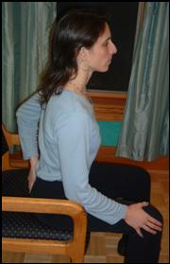

For this step, the order of hand
placement is important.

First put one hand (either one)
on the tailbone.

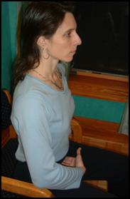

Put the middle and ring fingers of the other hand just above the pubic bone, in the soft fleshy area. Press inward with your fingertips that are above the pubic bone for a few seconds.

(The hand on the tailbone stays in place, but no pressure is exerted there.) Breathe in through the nose and out through the mouth as you do this.

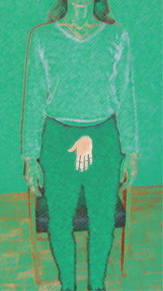
If you are not familiar with the location of your pubic bone, you can find it by placing the palm of one hand (with fingers pointing downward) just under the belly button. In most cases the fingertips will then just be touching the pubic bone. If you are pregnant, heavy, or have very short fingers, you may need to slide your hand downward slightly in order to touch the pubic bone. Again, for this exercise, press just above the pubic bone into the abdomen, rather than on the bone itself.

This completes The Un-Switching Protocol.

Copyright Deena Spear 2006

Breathing to Deepen the Un-switching

We discovered that the following breathing technique, adapted from ancient Yogic practices, further enhances un-switching when performed just after The Un-Switching Protocol. Use your right hand only, leaving your right thumb in position ready to gently press the right nostril closed, and your right index finger in position ready to press your left nostril closed:

Gently press the right nostril closed with the right thumb.
Inhale through the left nostril.
Hold the breath (or think of it as a pause) as you close the left nostril with the right index finger (while releasing the right thumb from the right nostril).
Exhale through the right nostril.
Hold the breath at the end of the exhale.
Inhale through the right nostril.
Hold the breath as you close the right nostril with the right thumb (while releasing the index finger from the left nostril).
Exhale through the left nostril.
Hold the breath.

This is one cycle. Repeat the cycle one more time.

An easy cadence to remember for one cycle could be:
Inhale, change
Exhale, hold
Inhale, change
Exhale, hold

Each element—inhale, exhale, change, and hold—is for the same time duration. This can vary from person to person. While no special time is necessary, about 3 seconds per element is a good rate for the exercise. By hold I mean a gentle pause, not a holding with effort. The instruction to “change,” which occurs after each inhale, means you are switching from closing off one nostril to closing off the other instead. During the finger/nostril change you are also holding (or pausing) the breath at the end of an inhale.

For more information including testing for switching, and also how to test for compatible foods, see “Additional Notes about Switching and Muscle Testing” in (or coming soon to) the Articles section of www.singingwoods.org.

Copyright Deena Spear 2006
Un-Switching At-a-Glance

Step 1. Diaphragm. Inhale through nose, exhale through mouth as you do this step.
Hands on the diaphragm point. Take 3 breaths, counting on the in-breath.

Step 2. In the Prophetic Position.
A. One hand on the diaphragm.

B. Press the back of the neck with palm.

C. Tongue on the roof of mouth at the top of arch.

D. Bend forward. Breathe in through the nose
and out through the mouth 4 to 6 times.

Step 3. Collarbones. Both Sides: inhale through nose. Exhale through nose or mouth as you do this step.
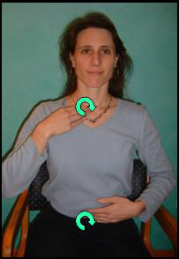
Right Side: Right hand index and middle fingers on right collarbone. Left hand index and middle fingers on belly button. Clockwise circles with both hands when viewed from front.

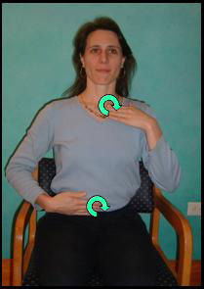
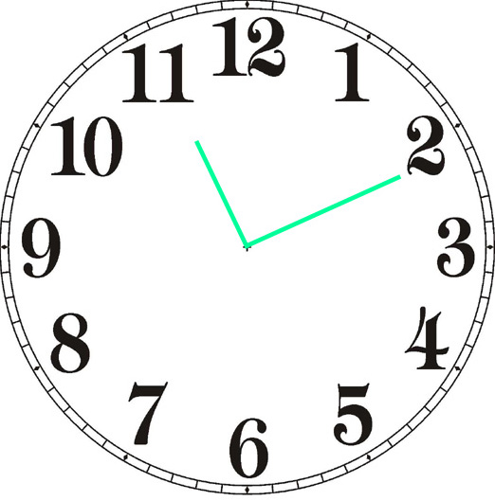
Left Side: Left hand index and middle fingers on left collarbone. Right hand index and middle fingers on belly button. Clockwise circles with both hands when viewed from front.

Step 4. Tailbone. Inhale through nose, exhale through mouth as you do this step.
A. One hand on tailbone.

B. Middle and ring fingers press briefly in soft
area just above the pubic bone.

To Deepen the Unswitching: Do yogic breathing as indicated in long version.

www.singingwoods.org Copyright Deena Spear 2006

